**CO600 User Stories**

**Story:** As a user, I want to compare my trading portfolio with another user within a specific date range that I can select to be displayed both as a graph and list weekly records of data.

**Details**: Once a user has finished a simulation, the results (decisions that were made) will be recorded within the storage, ensuring that the results will be associated to that specific user account. This can then be retrieved to be showcased on the graph, if a user wants to compare their results with another specific user when searching the username, due to the fact that the results associated to the user will be recorded.

**Requirements**

Table storage, Controller, API (requests for various data), Authentication System, Filter Option

|  |  |
| --- | --- |
| *Use case name* | Comparing data |
| *Participating actors* | User, Table Storage, API (Controller) |
| *Flow of events:*  *Normal flow* | 1. User is authenticated through log in system  2. User directs to the comparison section of website  3. User enters username of the user they want to compare with  4. User specifies the date range for the time period  5. User clicks the compare button  6. Request is sent to API for the retrieval of both users data  7. Comparison data is visually represented on graph |
| *Pre-condition* | User is authenticated |
| *Post-condition* | User can view comparison data of both users |

**Diagrams**

**Use Case Diagram**

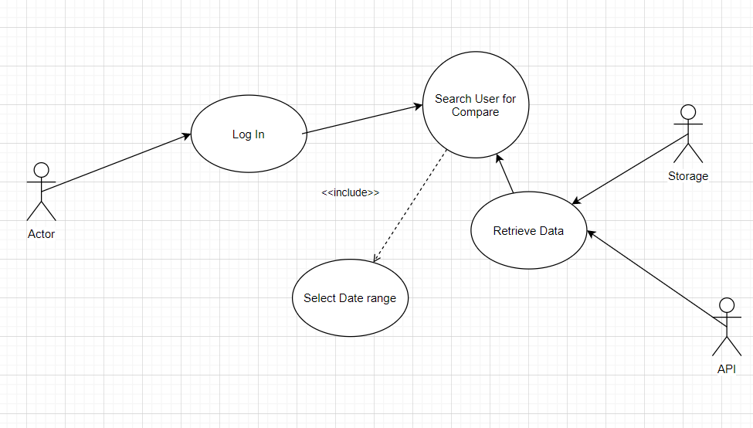

**Sequence Diagram**